EE223 HW1

Enrique Hernandez

9/12/18

1. Ids-Vds Characteristics

Schematic (1 & 2)

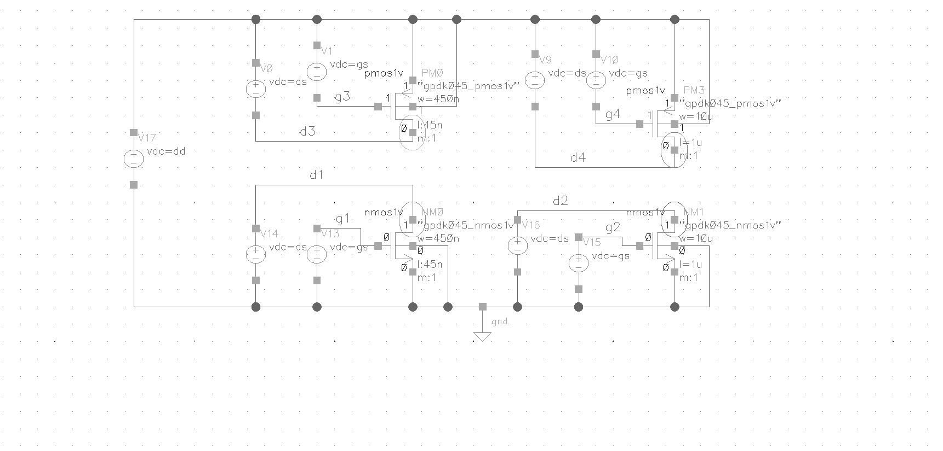

* 1. Dc Nmos1v and Pmos1v sweep: Vds=1V, Vgs=1V. Sweep Vds from 0V to 1V in 10mV step

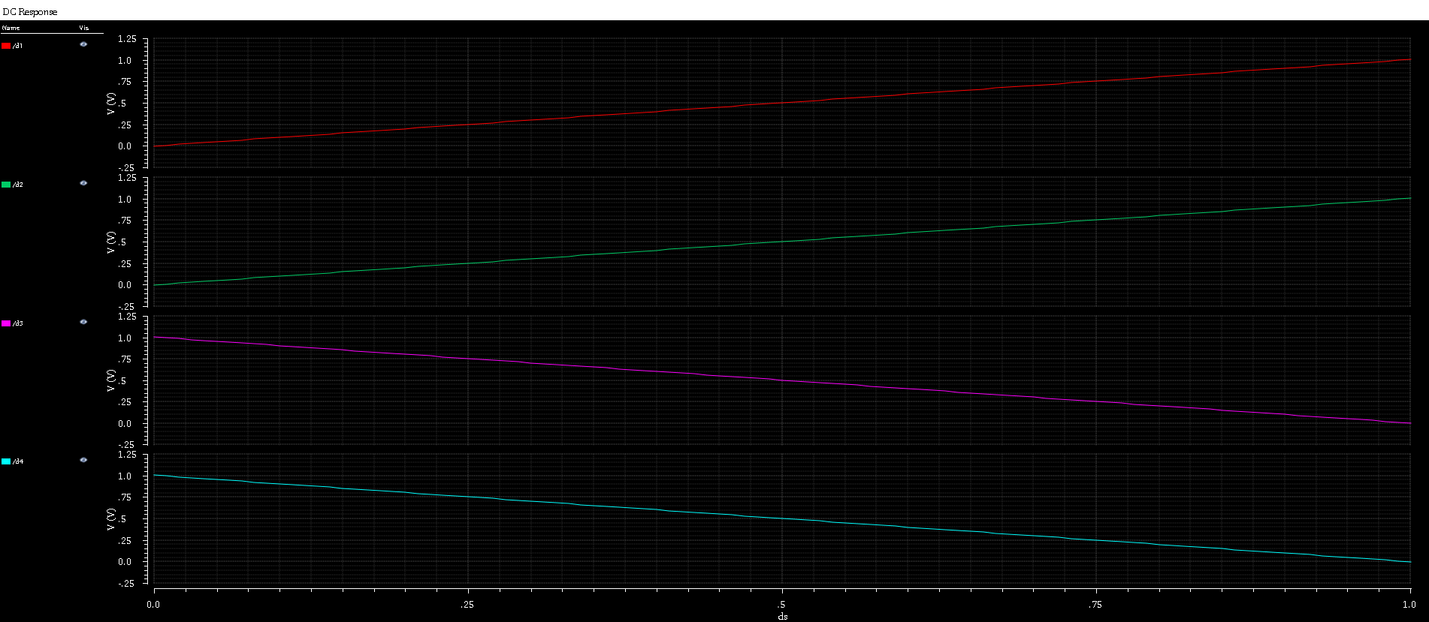

Figure 2: DC Id vs Vds

a_b: Nmos1v and Pmos1v Parametric analysis: Sweep Vgs from 0V to 1V in 200mV step.

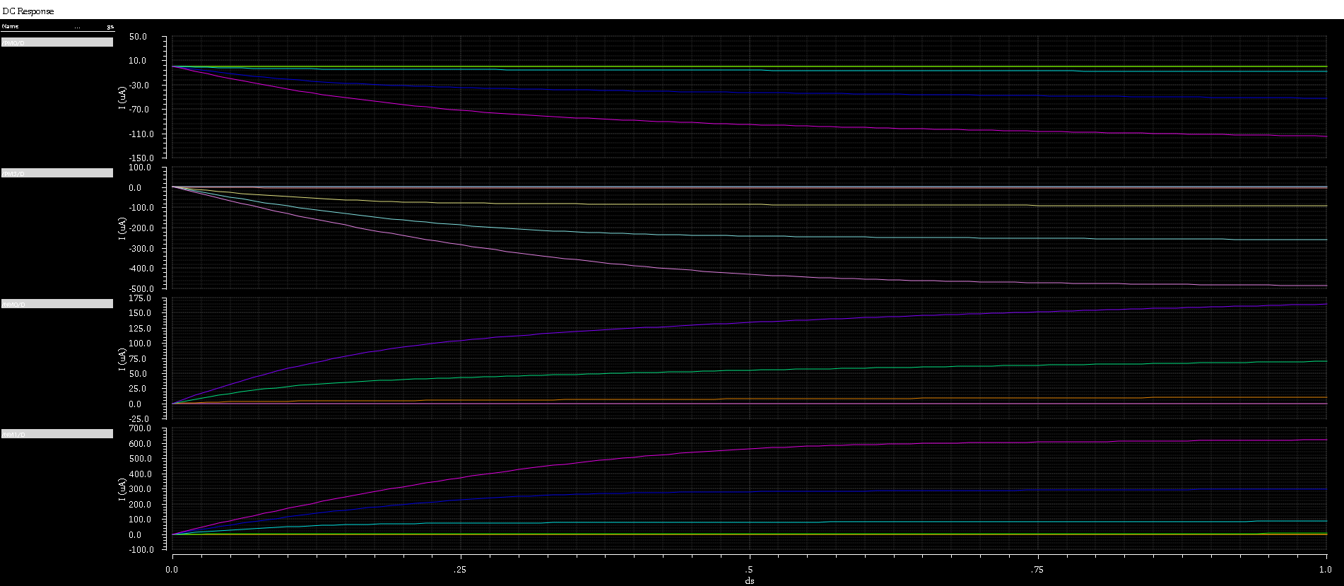

Figure 3: Ids-Vds

b_a: Dc Nmos2v and Pmos2v sweep: Vds=1.8V, Vgs=1.8V. Sweep Vds from 0V to 1.8V in 300mV step

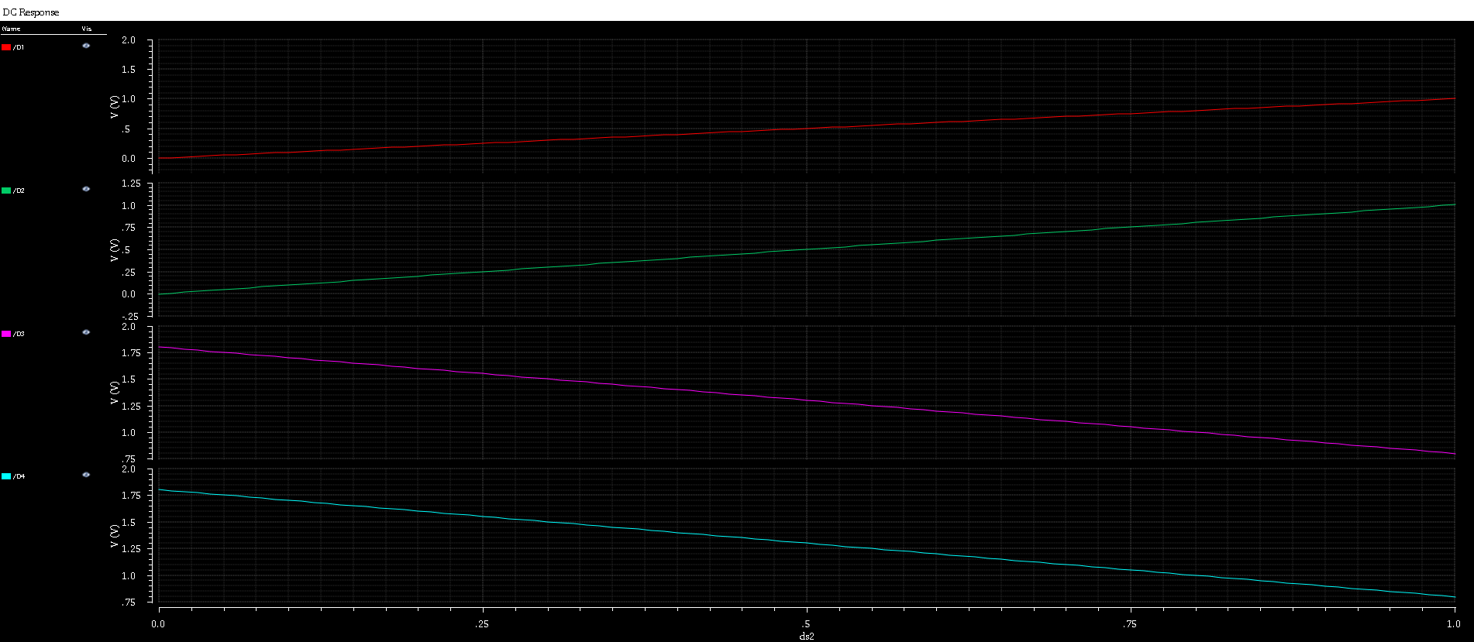

Figure 4: Ids vs Vds

b_b: Nmos2v and Pmos2v Parametric analysis: Sweep Vgs from 0V to 1V in 200mV step.

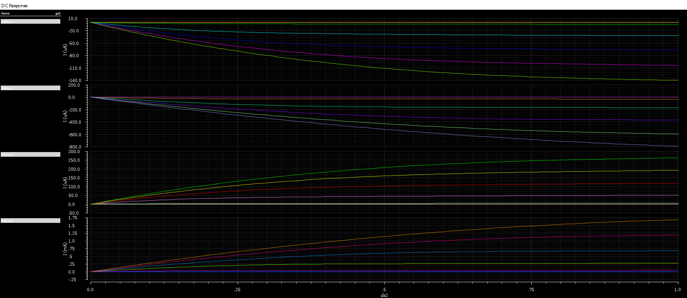

Figure 5: Ids-Vds

2: Ids-Vgs Characteristics

1. Dc Nmos1v and Pmos1v sweep: Vds=1V, Vgs=1V. Sweep Vgs from 0V to 1V in 10mV step.

a_b: Nmos1v and Pmos1v Parametric analysis: Sweep Vgs from 0V to 1V in 200mV step.

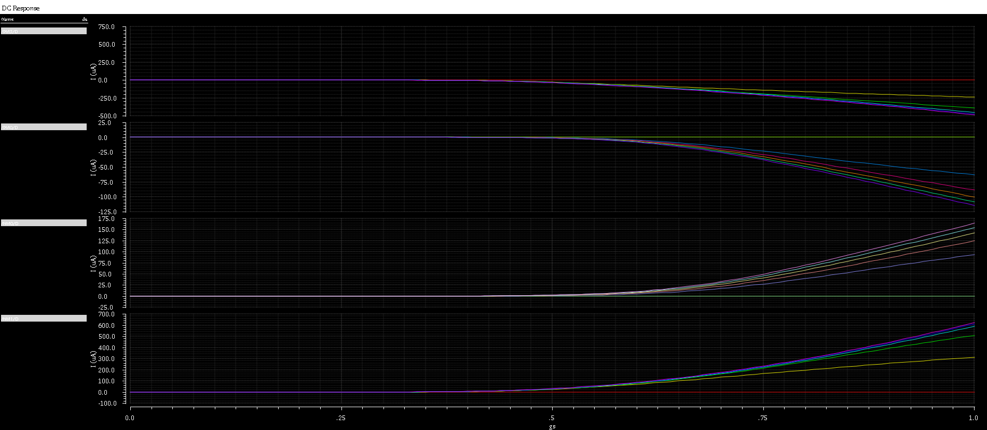

Figure 6: Ids-Vgs

a_c: Nmos1v and Pmos1v Parametric analysis: Sweep Vgs from 0V to 1V in 200mV step derivative (gm)

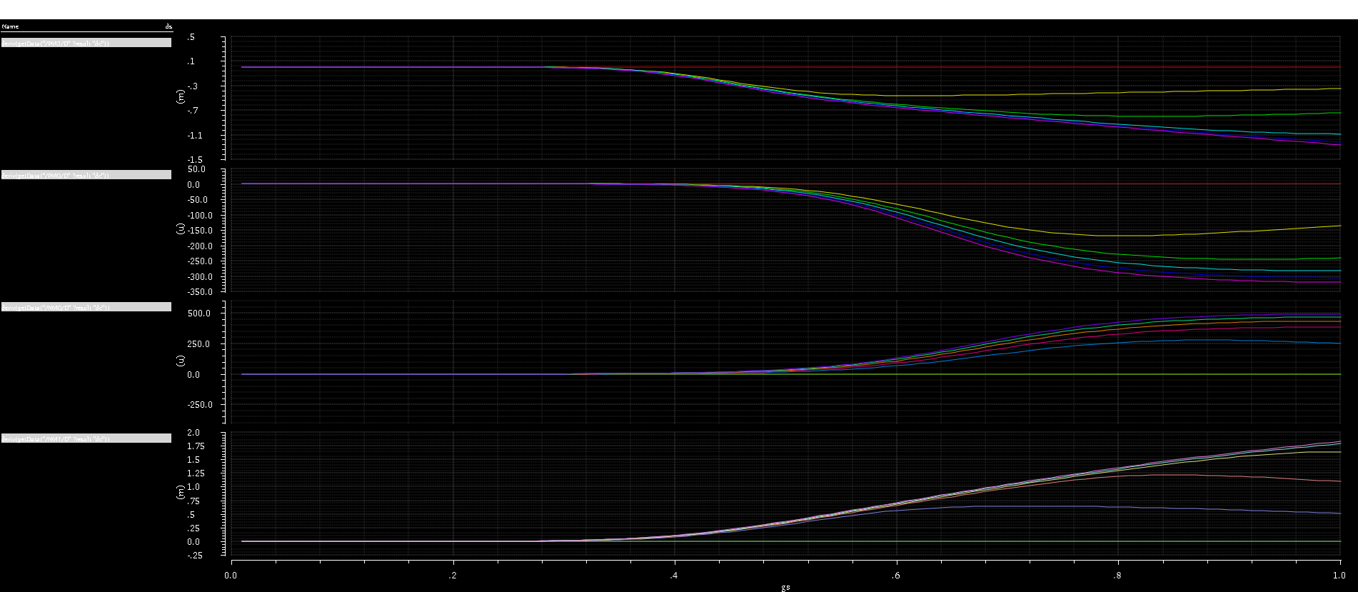

Figure 7: Vgs vs gm

b_a. Dc Nmos2v and Pmos2v sweep: Vds=1V, Vgs=1V. Sweep Vgs from 0V to 1V in 10mV step.

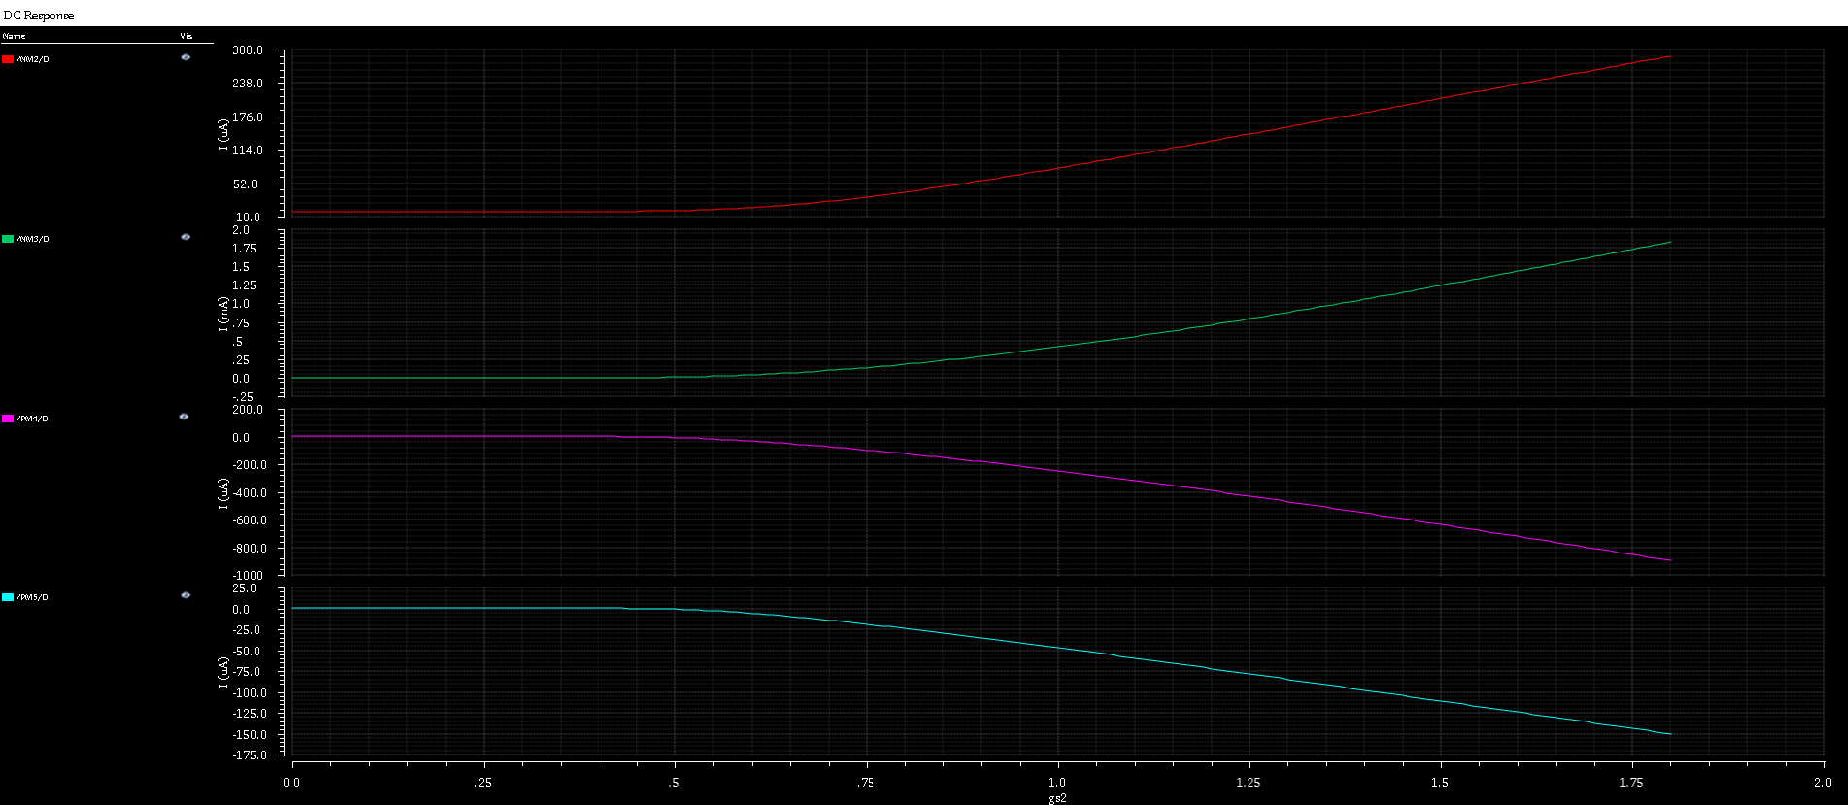

Figure 8: Ids Vs Vgs

b_b. Nmos2v and Pmos2v Parametric analysis: Sweep Vgs from 0V to 1V in 200mV step.

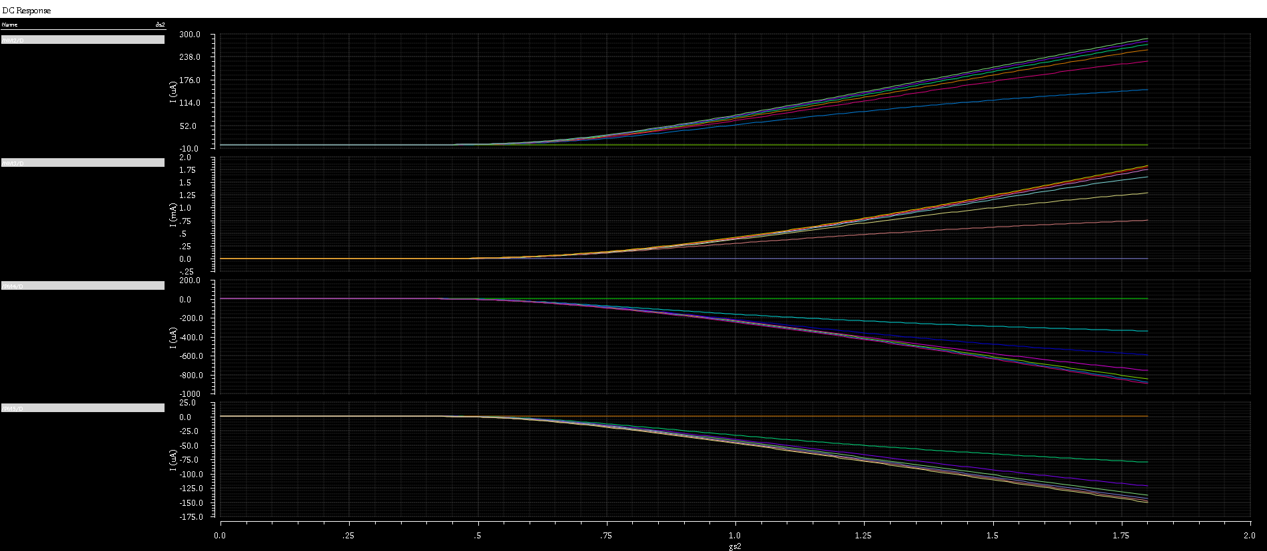

Figure 8: Ids-Vgs

3. Vt dependence on Channel Length

Schematic (3 & 4)

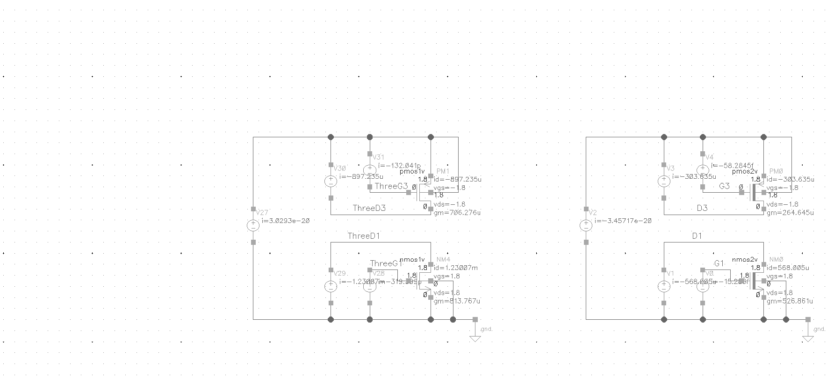

A_a: Nmos1v and Pmos1v threshold voltage vs channel plot

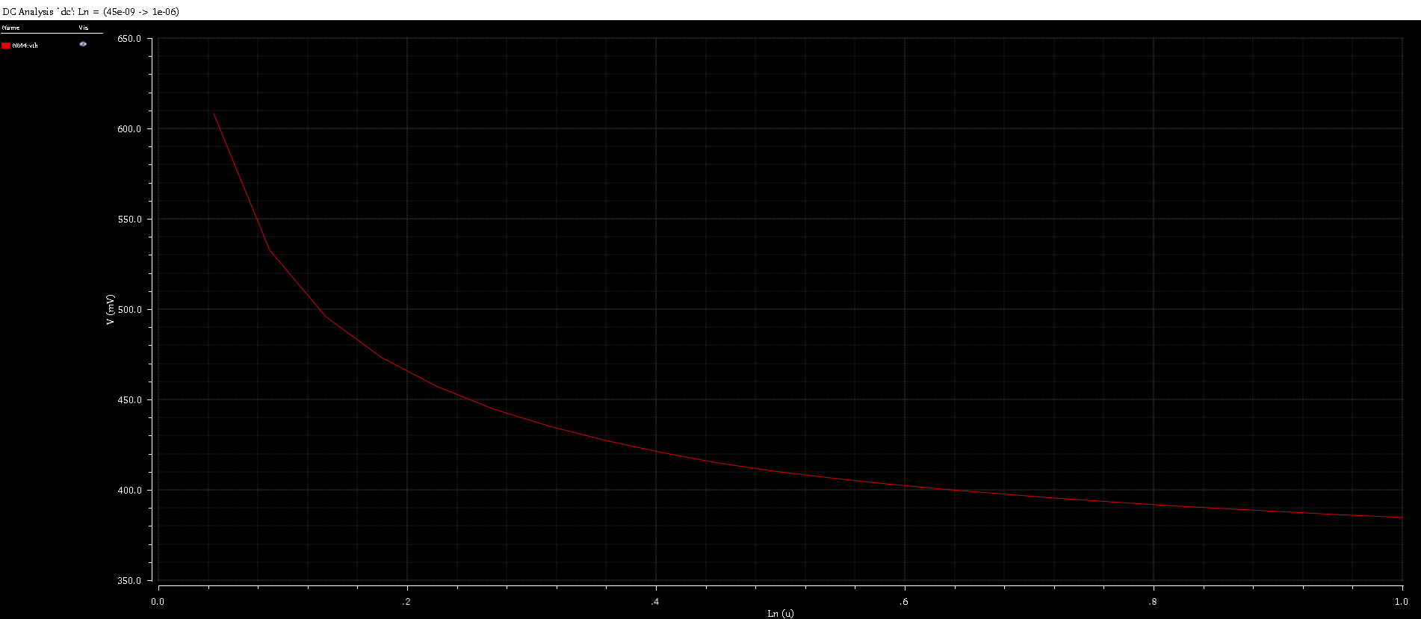

Figure 9: Nmos1v Vth vs Length DC sweep (Nmos1v L sweep)

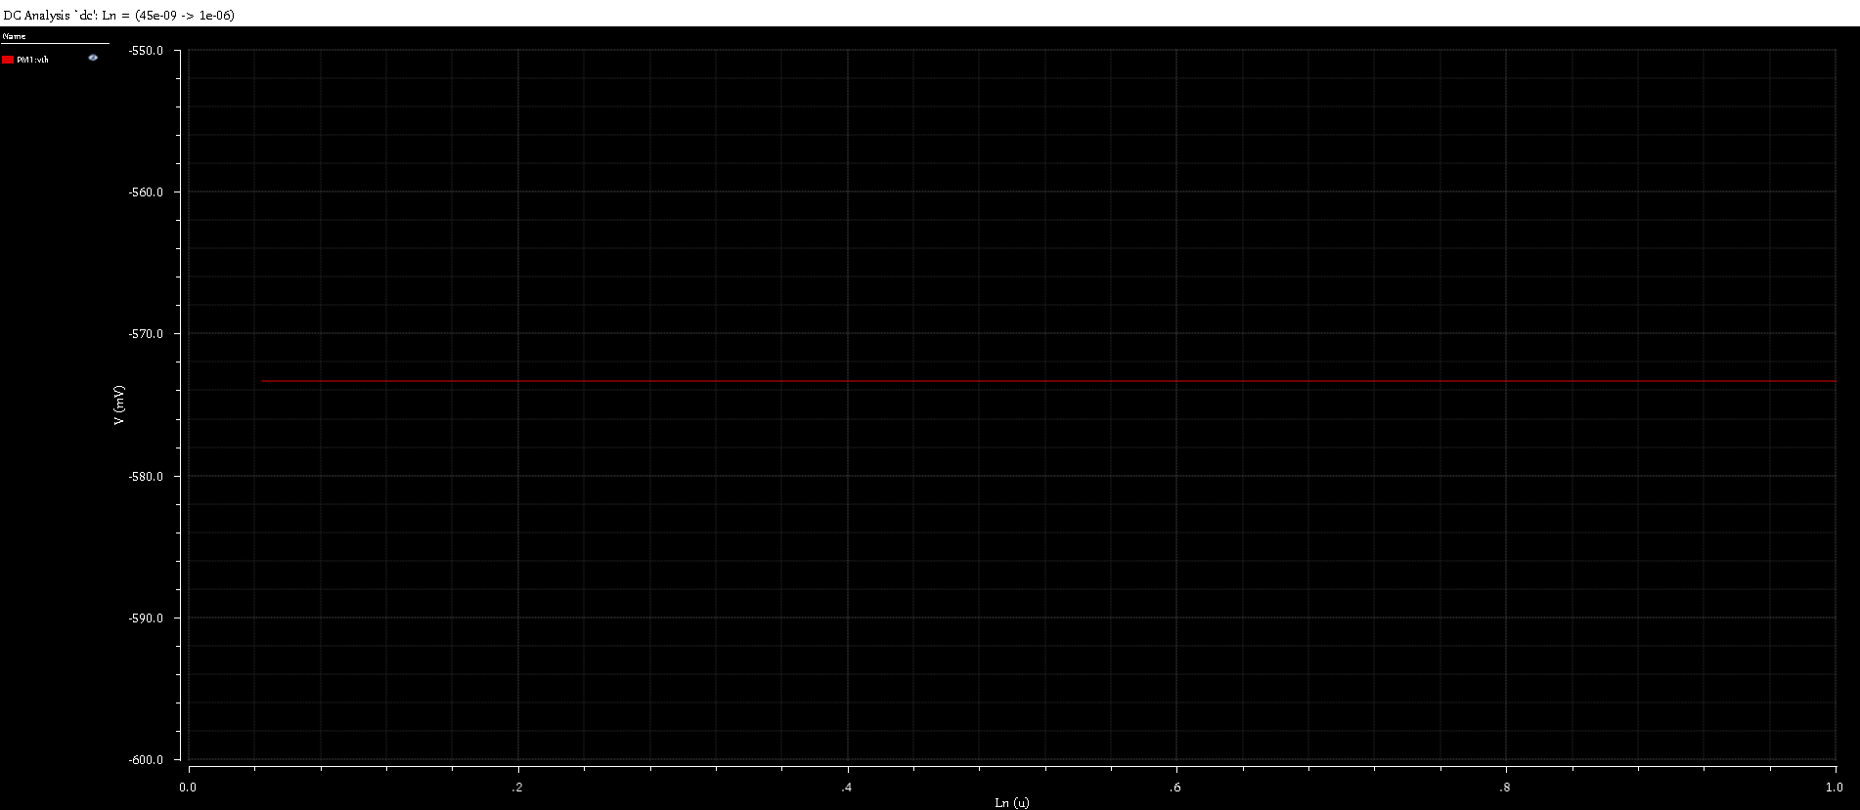

Figure 10: Pmos1v Vth vs Length DC sweep (Pmos1v L constant)

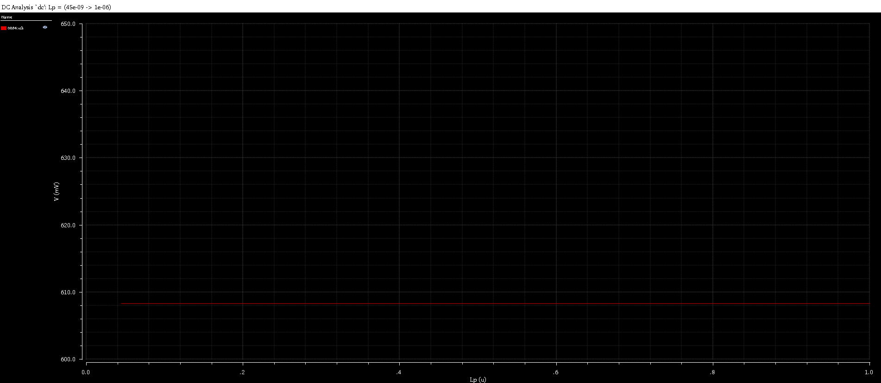

Figure 11: Nmos1v Vth vs Length DC sweep (Nmos1v L constant)

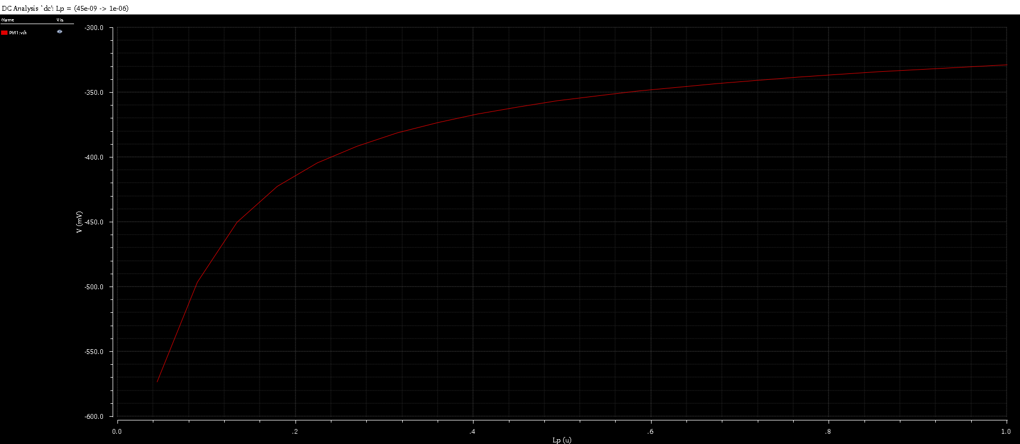

Figure 12: Pmos1v Vth vs Length DC sweep (Pmos1v L sweep)

b: Nmos2v and Pmos2v threshold voltage vs channel plot

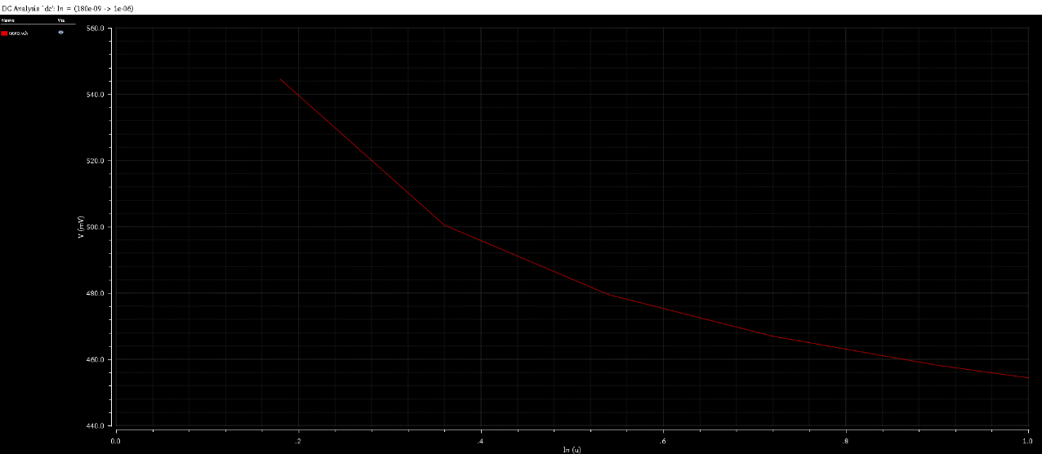

Figure 12: Nmos2v Vth vs Length (Nmos2v L sweep)

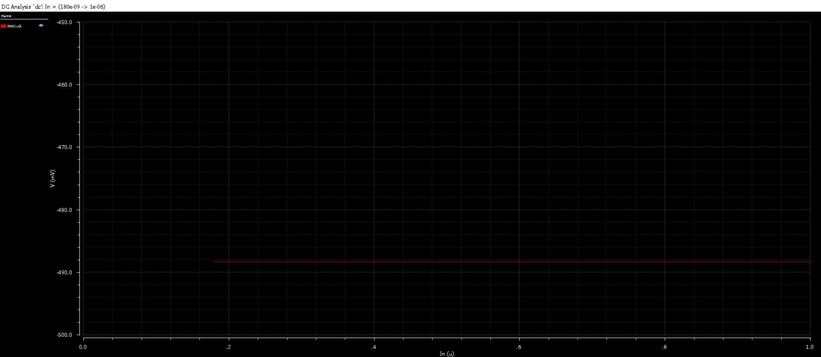

Figure 12: Pmos2v Vth vs Length (Pmos2v L constant)

4: Vt dependence on Channel Width

a: Sweep WN from 120 nm to 1.2um in 120nm step. Plot Vt vs. W

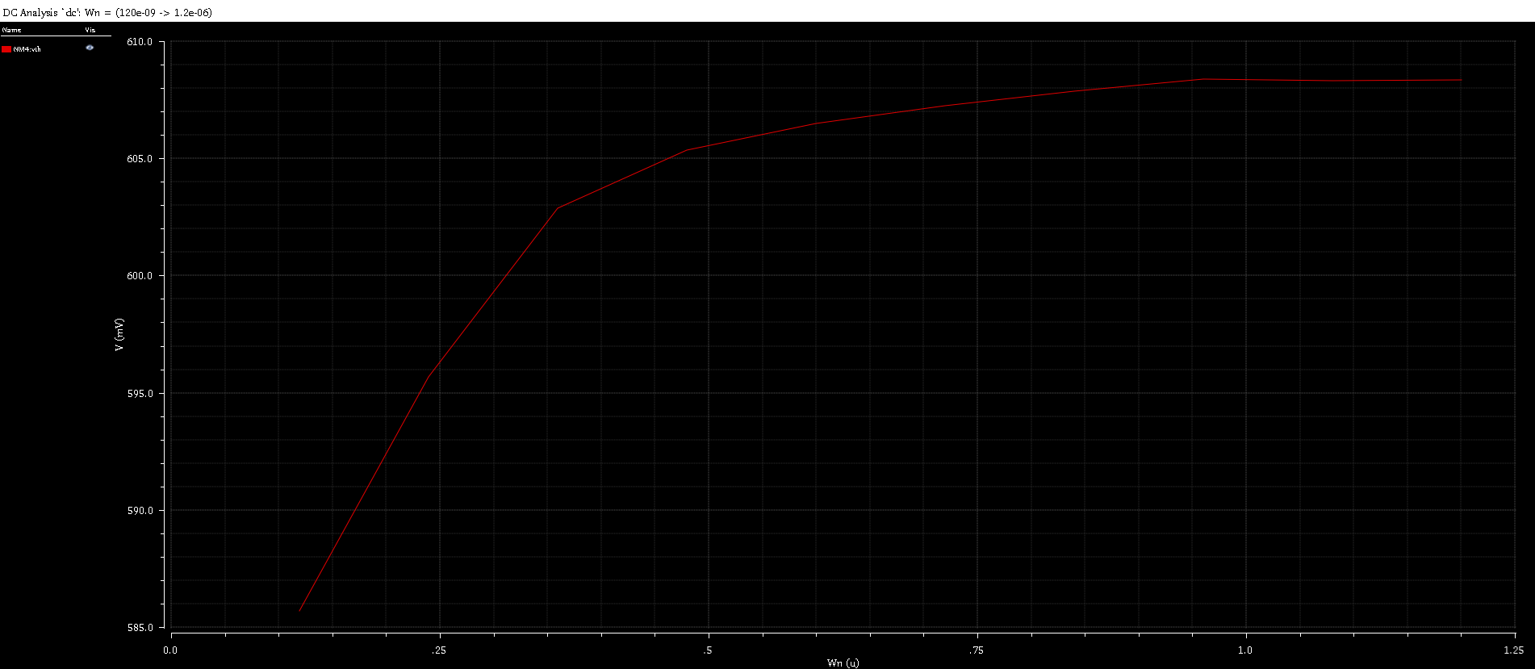

Figure 13: Nmos1v Vth vs Width (Nmos1v W sweep)

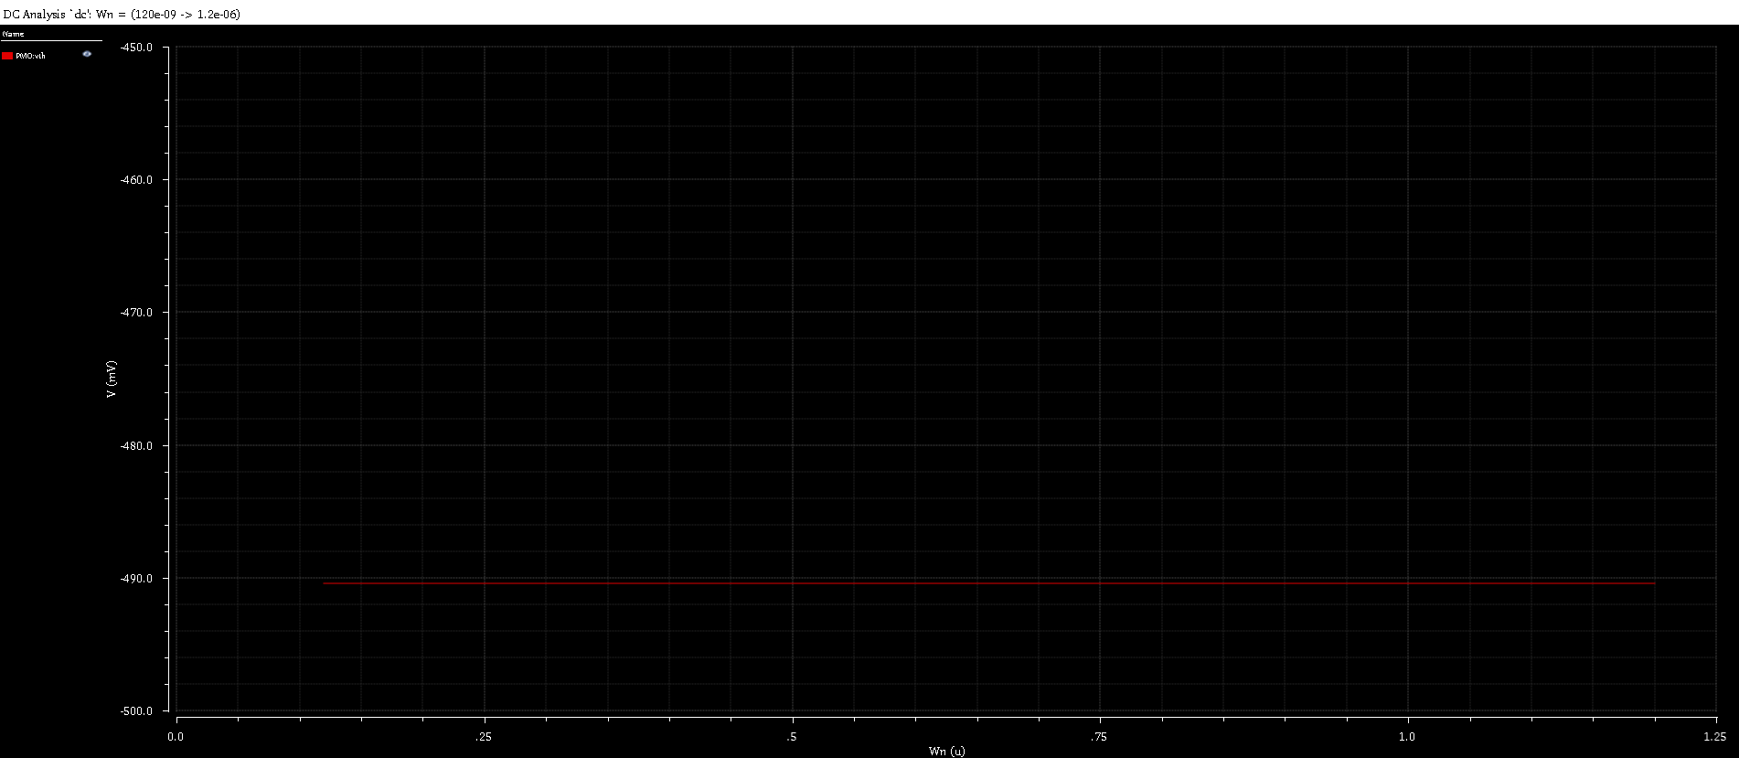

Figure 14: Pmos1v Vth vs Width (Pmos1v W constant)

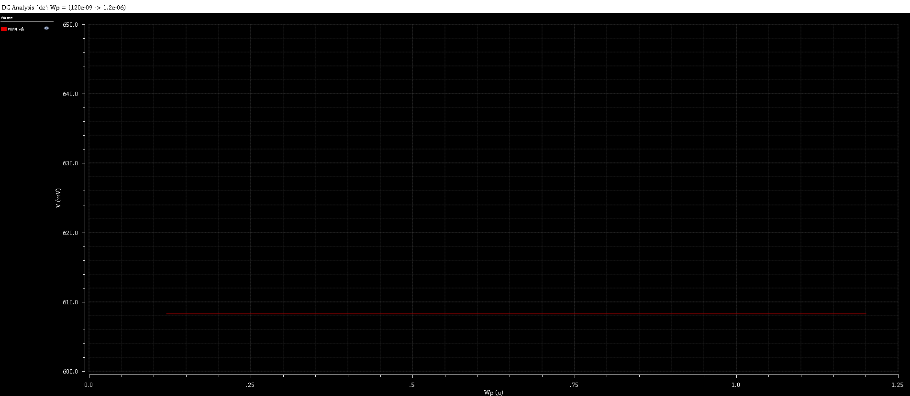

Figure 15: Nmos1v Vth vs Width (Nmos1v W constant)

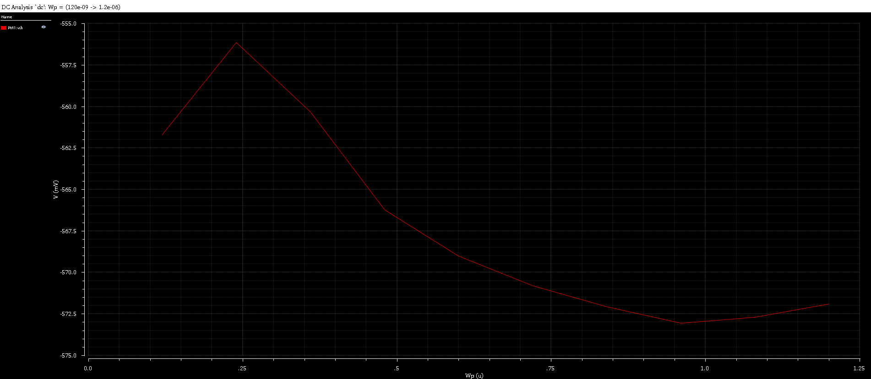

Figure 16: Pmos1v Vth vs Width (Pmos1v W sweep)

1. Repeat the above for nmos2v and pmos2v.

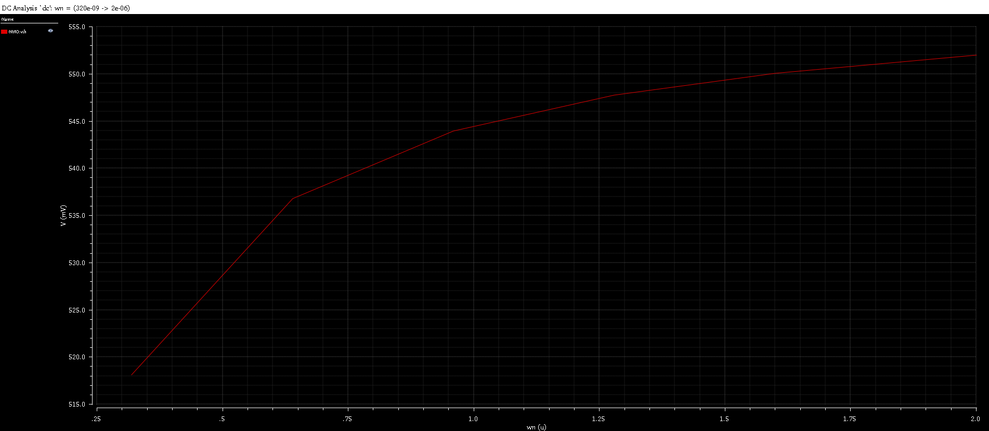

Figure 17: Nmos2v Vth vs Width (Nmos2v W sweep)

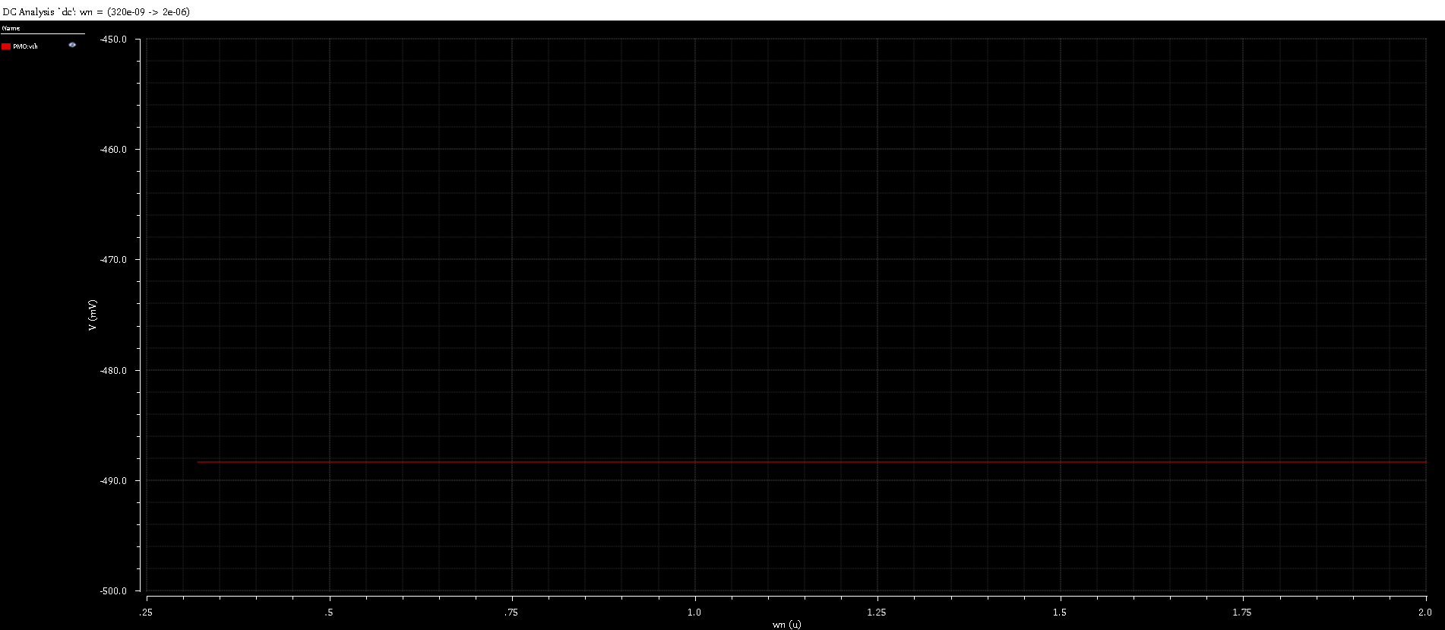

Figure 18: Pmos2v Vth vs Width (Pmos2v constant)

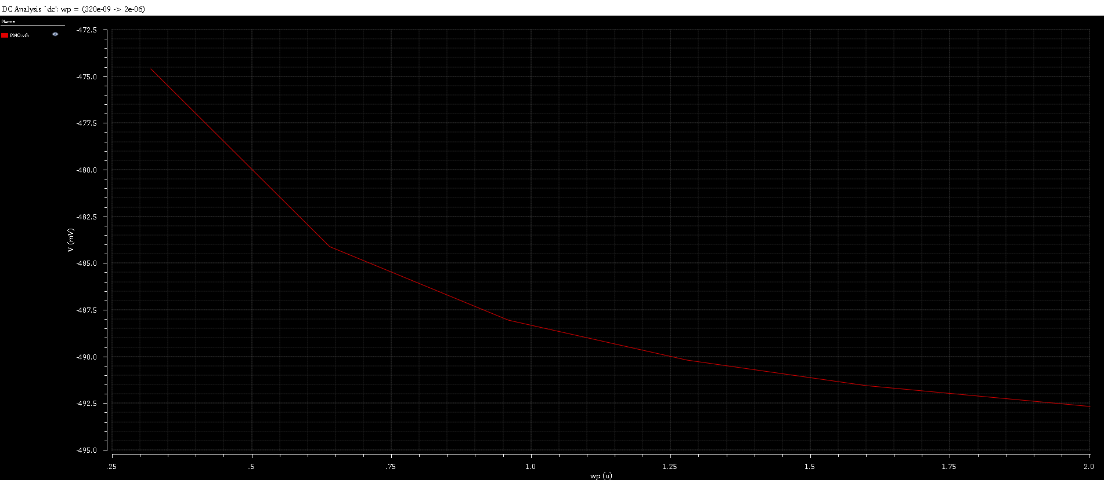

Figure 19: Pmos2v Vth vs Width (Pmos2v W sweep)

5. MOS parameter extraction

Schematic

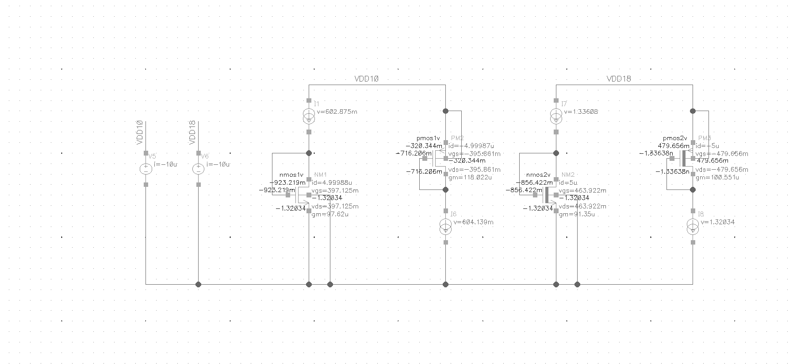

1. Run a DC simulation to find out various transistor parameters at a given operating condition.

|  |  |  |  |  |  |
| --- | --- | --- | --- | --- | --- |
| Parameter | Source | Nmos1v | Pmos1v | Nmos2v | Pmos2v |
| Id | given | 5.00E-06 | 5.00E-06 | 5.00E-06 | 5.00E-06 |
| Vth | from sim | 0.398453 | -3.35E-01 | 4.71E-01 | -4.16E-01 |
| Vdsat | from sim | 0.073048 | -7.28E-02 | 7.72E-02 | -9.72E-02 |
| Vth+Vdsat | calculation | 0.471501 | -4.07E-01 | 5.48E-01 | -5.13E-01 |
| Vgs | from sim | 0.397125 | -3.96E-01 | 4.64E-01 | -4.80E-04 |
| 2Id/Vdsat | calculation | 1.37E-04 | -1.37E-04 | 0.00013 | -1.03E-04 |
| gm | from sim | 9.76E-05 | 1.18E-04 | 9.14E-05 | 1.01E-04 |
| gds | from sim | 2.66E-06 | 2.08E-06 | 2.44E-06 | 1.72E-06 |
| gm/gds | calculation | 3.68E+01 | 5.68E+01 | 3.74E+01 | 5.84E+01 |
| gain(dB) | 20log(gm/gds) | 3.13E+01 | 3.51E+01 | 3.15E+01 | 3.53E+01 |
| betaeff | from sim | 3.36E-03 | 2.92E-03 | 3.05E-03 | 1.69E-03 |
| Kp(=ucox) | calculation | 0.000336 | 0.000292 | 0.000305 | 0.000168824 |

b) For the circuit shown above, sweep temperature from -40C to 160C in 40C step and plot Vt vs. Temp and KP vs. Temp for all transistors.

“betaeff = (W/L) * KP”

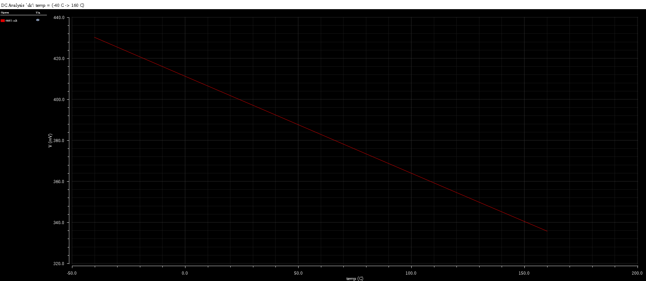

Figure 20: Nmos1v Vth vs Temperature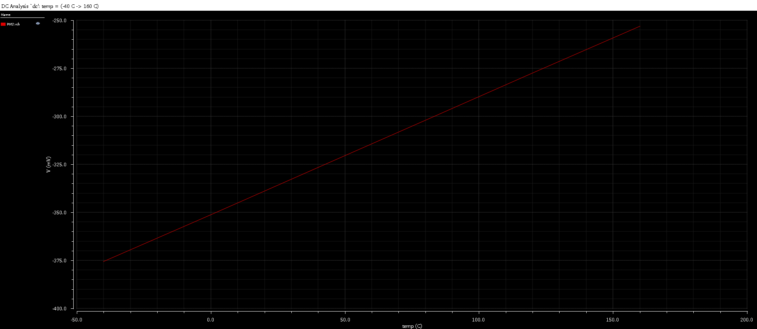

Figure 21: Pmos1v Vth vs Temperature

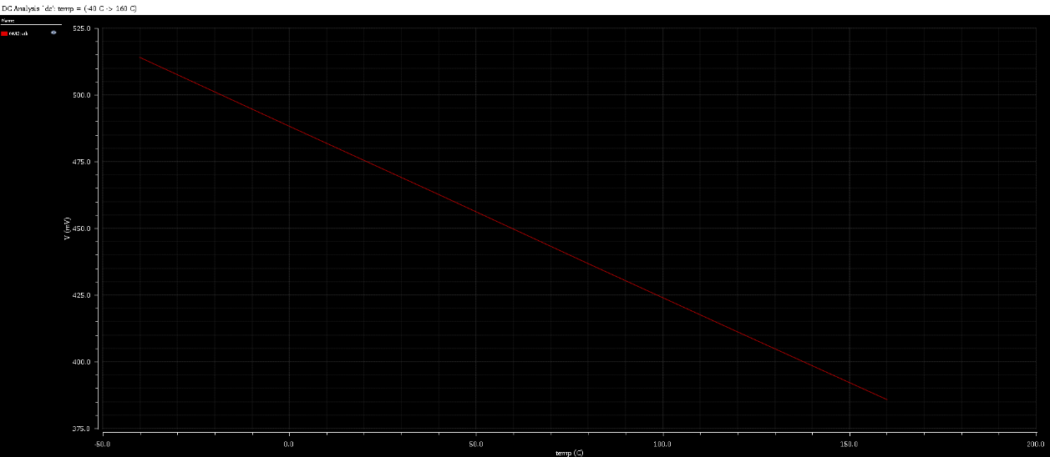

Figure 21: Nmos2v Vth vs Temperature

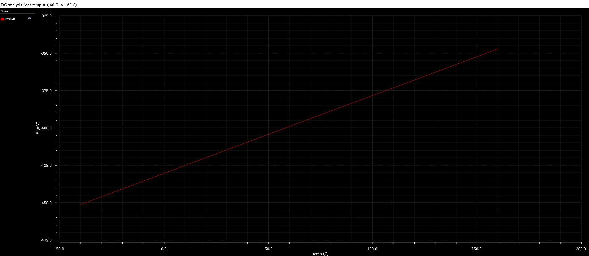

Figure 22: Pmos2v Vth vs Temperature

Figure 23: Pmos1v Kp vs Temperature

Figure 24: Nmos2v Kp vs Temperature

Figure 25: Pmos2v Kp vs Temperature